Ratio Faces

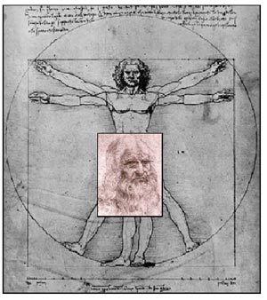

Leonardo da Vinci famously used the golden ratio in setting out the proportions of the human body.

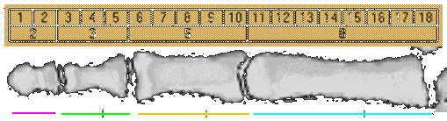
Within your hands you will likely find the golden ratio.
Our fingers have three sections. The proportion of the first two to the full length of the finger gives the golden ratio (with the exception of the thumbs). You can also see that the proportion of the middle finger to the little finger is also a golden ratio.

Record your results here:

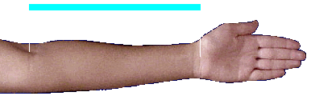
Try this:

What do you find?

The golden ratio is also found in the structure of the human face. In this activity, you will use the golden ratio proportions to draw a remarkably authentic face. You will also see what the same face would look like with two different underlying ratios.

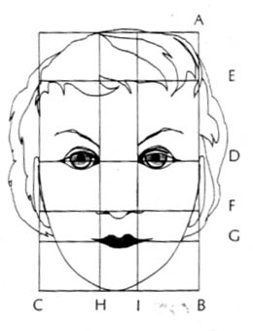
On a clean piece of paper, in a landscape orientation, draw three 8 cm lines about three or four cm from the bottom. These will serve as the width of our rectangular canvas.

The middle line will be our golden rectangle. To find the length, AB, solve the proportion

AB = 12.6 cm

Locate the other points according by the following:

AD = ½ AB

Show your work in an organized fashion for solving the proportions and finding the length of all the segments

After you have laid out the grid, use symmetry to fill in the features. You may want to make a self-portrait!

For the other two faces, we will use the dynamic rectangle ratios

Repeat the procedure from above, using the approximation 1.4 and 1.7 in your proportions.

Although the differences in the proportions are small, you should find the differences in the resulting faces to be significant!

